实验一：布局与国际化

使用合适的布局方法（不用约束布局），实现如下界面。并实现软件国际化，当汉语人群使用软件时，呈现左下界面，而英语人群使用软件时，呈现右下界面。

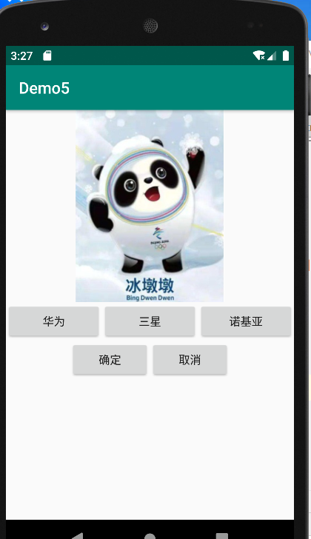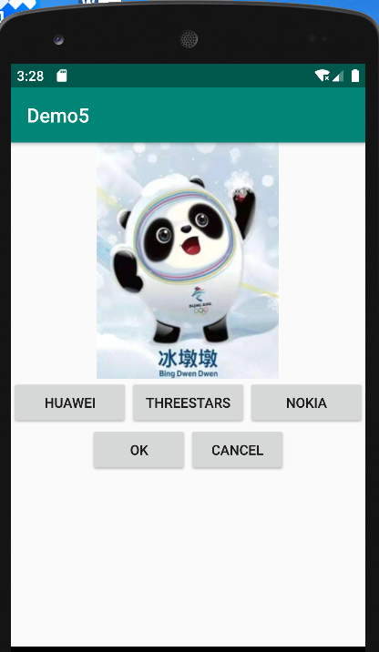

*<?*xml version="1.0" encoding="utf-8"*?>  
<*LinearLayout  
 xmlns:android="http://schemas.android.com/apk/res/android"  
 xmlns:tools="http://schemas.android.com/tools"  
 xmlns:app="http://schemas.android.com/apk/res-auto"  
 android:layout_width="match_parent"  
 android:layout_height="match_parent"  
 tools:context=".MainActivity"  
 android:orientation="vertical"*>  
  
 <*LinearLayout  
 android:layout_weight="4"  
 android:layout_width="match_parent"  
 android:layout_height="0dp"*>  
  
 <*ImageView  
 android:layout_width="match_parent"  
 android:layout_height="match_parent"  
 android:layout_weight="1"  
 android:layout_marginVertical="@dimen/cardview_default_elevation"  
 app:srcCompat="@drawable/shf"  
 android:id="@+id/imageView"  
 */>  
 </*LinearLayout*>  
  
 <*LinearLayout  
 android:layout_weight="1"  
 android:layout_width="match_parent"  
 android:layout_height="0dp"*>  
 <*Button  
 android:layout_width="wrap_content"  
 android:layout_height="wrap_content"  
 android:id="@+id/hw"  
 android:text="@string/hw"  
 android:layout_weight="1"  
 tools:ignore="NestedWeights"*/>  
  
 <*Button  
 android:layout_width="wrap_content"  
 android:layout_height="wrap_content"  
 android:id="@+id/sx"  
 android:text="@string/sx"  
 android:layout_weight="1"*/>  
  
 <*Button  
 android:layout_width="wrap_content"  
 android:layout_height="wrap_content"  
 android:id="@+id/njy"  
 android:text="@string/njy"  
 android:layout_weight="1"*/>  
 </*LinearLayout*>  
  
  
 <*LinearLayout  
 android:layout_weight="1"  
 android:layout_width="match_parent"  
 android:layout_height="0dp"*>  
 <*Button  
 android:layout_width="wrap_content"  
 android:layout_height="wrap_content"  
 android:id="@+id/ok"  
 android:text="@string/ok"  
 android:layout_weight="1"*/>  
  
 <*Button  
 android:layout_width="wrap_content"  
 android:layout_height="wrap_content"  
 android:id="@+id/cancle"  
 android:text="@string/cancle"  
 android:layout_weight="1"*/>  
 </*LinearLayout*>  
  
  
  
</*LinearLayout*>*

